1. Layer 1: Heterogeneous Nucleation Onset and Induction Lag
1.1 Dewpoint Temperature
Condensation begins when the surface temperature$T_{s}$ falls below the dewpoint $T_{dp}$. The
dewpoint is computed from ambient temperature $T_{amb}(℃$) and relative humidity $RH∈(0,1]$ via the August–Roche–Magnus approximation:
$$T_{dp}=\frac{b\left[\ln\left(RH\right)+\frac{aT_{amb}}{b+T_{amb}}\right]}{a-\ln\left(RH\right)-\frac{aT_{amb}}{b+T_{amb}}}, a=17.625, b=243.04\left(℃\right) (1)$$
The subcooling, the primary thermodynamic driver of condensation, is:
$$∆T_{sub}=T_{dp}-T_{s}, ∆T_{sub}>0⟹condensation thermodynamically possible (2)$$

1.2 Gibbs Free-Energy Barrier (Classical Nucleation Theory)
Before a condensate film appears, water-vapor molecules must surmount an energy barrier to form a stable nucleus. For heterogeneous nucleation on a substrate with contact angle $θ_{c}$, classical nucleation theory (CNT) gives:
$$∆G^{*}=f\left(θ_{c}\right)∆G_{hom}^{*}, ∆G_{hom}^{*}=\frac{16πσ^{3}}{3{\left(∆G_{v}\right)}^{2}} (3)$$
Where $σ$ is the liquid-vapor surface tension $\left[J m^{-3}\right]$. The Fletcher heterogenous nucleation factor is:
$$f\left(θ_{c}\right)=\frac{\left(2+\cos{θ_{c}}\right){\left(1-\cos{θ_{c}}\right)}^{2}}{4}, f\left(θ_{c}\right)∈\left[0,1\right] (4)$$

Table 1 lists representative contact angles and their effect on the induction lag.
Table 1: Nominal contact angles and Fletcher factors for enclosure window coatings. The relative $t_{ind}$ multiplier is with respect to untreated glass.
Surface treatment | $$θ_{c}$$ | $$f\left(θ_{c}\right)$$ | Relative $t_{ind}$
Untreated glass | $${20}^{o}$$ | 0.006 | Baseline (rapid onset)
Hydrophilic coating | $${10}^{o}$$ | 0.001 | Shorter (faster nucleation)
Hydrophobic coating | $${100}^{o}$$ | 0.206 | ∼ 30× longer
Superhydrophobic | $${150}^{o}$$ | 0.933 | ∼ 150× longer

1.3 Nucleation Rate
The nucleation rate per unit surface area is:
$$J∝exp\left(-\frac{∆G^{*}}{k_{B}T}\right) ∝exp\left(-\frac{f\left(θ_{c}\right)σ^{3}}{k_{B}T{\left(∆T_{sub}\right)}^{2}}\right) (5)$$
Where the ${\left(∆T_{sub}\right)}^{-2}$ scaling comes from $∆G_{v}∝∆T_{sub}$ near saturation (Clausius-Clapeyron linearization).
1.4 Engineering Induction Lag
Inverting J and collecting all prefactors into the empirical coefficient $k_{ind}$ gives the induction
lag:
$$t_{ind}=k_{ind}\frac{f\left(θ_{c}\right)}{{\left(∆T_{sub}\right)}^{n_{ind} }} (6)$$
2. Layer 2: Coverage Growth and Optical Attenuation
2.1 Logistic Coverage-Fraction Model
After $t_{ind}$, condensate droplets nucleate, grow by vapor diffusion, and coalesce. The fractional surface coverage $C(t)∈\left[0,1\right]$ during the growth phase is modelled as a logistic function:
$$C_{rise}\left(t\right)=\frac{C_{max}}{1+exp\left(-\frac{t-t_{ind}-t_{1/2}}{w_{rise}}\right)}, t_{ind}<t<t_{heat} (7)$$
Where $t_{1/2}=1.5w_{rise}$ centers the inflection point after onset, and the rise width scales with subcooling as:
$$w_{rise}=\frac{w_{0}}{\sqrt{∆T_{sub}}} (8)$$
2.2 Plateau Coverage Level
The maximum coverage $C_{max}$ is set by the balance between condensation driving force $(∆T_{sub})$ and available vapor supply (RH):
$$C_{max}=C_{max,0}\left(1-e^{{-∆T_{sub}}/{{∆T}_{char}}}\right)∙{RH}^{n_{RH}} (9)$$
2.3 Optical Transmittance: Beer–Lambert Kernel
Coverage $C(t)$ is mapped to transmittance $τ(t)$ via the Beer-Lambert law:
$$τ\left(t\right)=exp\left(-α_{eff}∙C(t)\right), α_{eff}=-\ln{τ_{min} (10)}$$

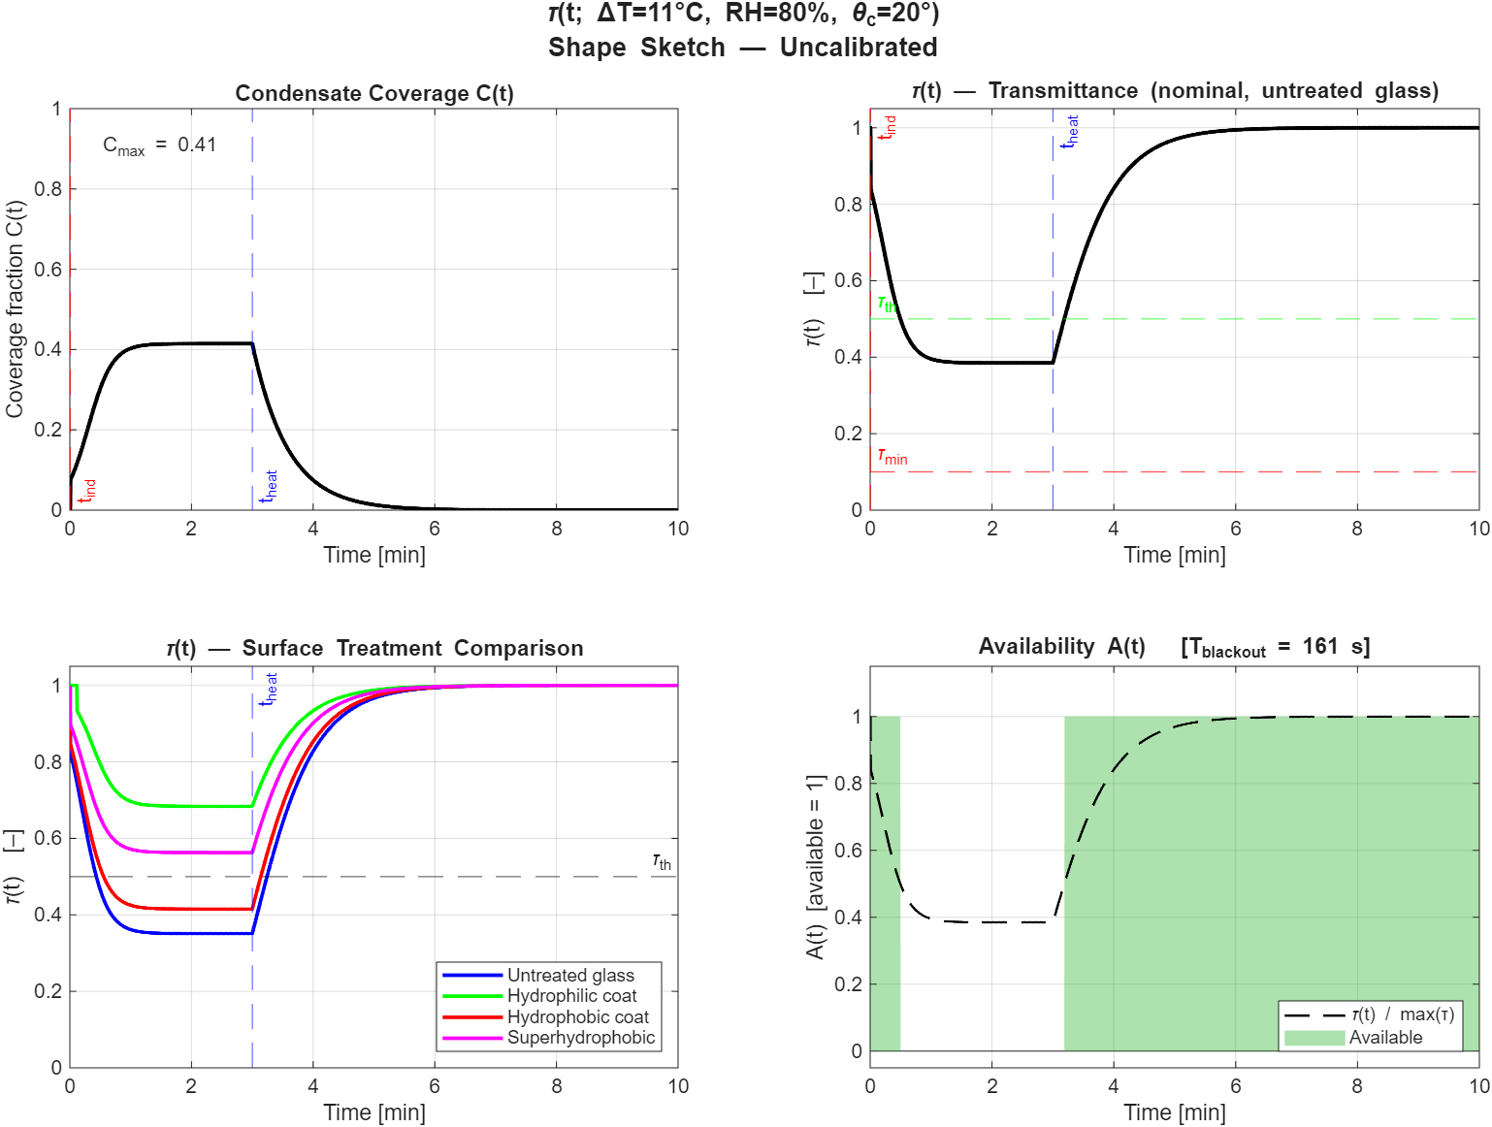
Fig 1. $τ\left(t\right)$ Model
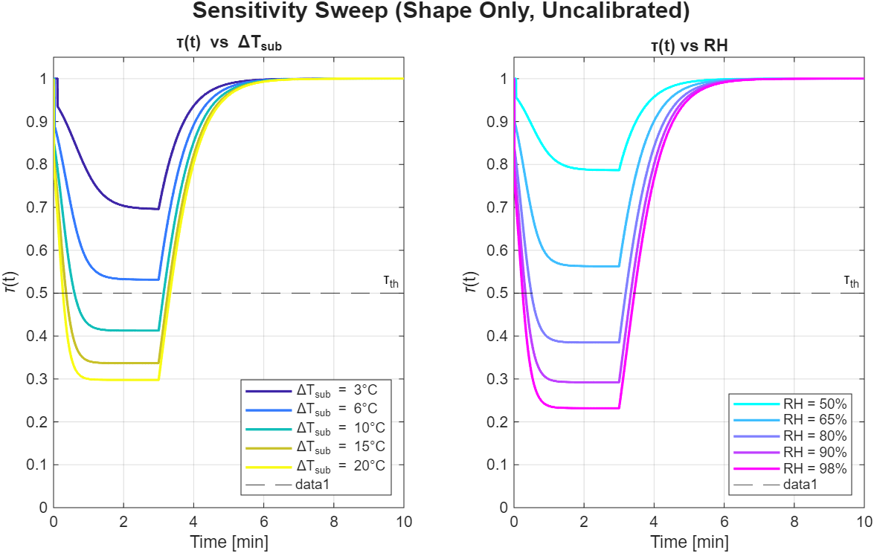
Fig 2. Sensitivity sweep $∆T$
References:
- Fletcher, N. H. (1958). Size effect in heterogeneous nucleation. Journal of Chemical Physics, 29(3), 572–576. https://doi.org/10.1063/1.1744540
- Carey, V. P. (2008). Liquid-vapor phase-change phenomena (2nd ed.). Taylor & Francis.
- Alduchov, O. A., & Eskridge, R. E. (1996). Improved Magnus Form Approximation of Saturation Vapor Pressure. Journal of Applied Meteorology and Climatology, 35(4), 601-609. https://doi.org/10.1175/1520-0450(1996)035<0601:IMFAOS>2.0.CO;2
- Thomas, T. M., Mahapatra, P. S., Ganguly, R., & Tiwari, M. K. (2023). Preferred mode of atmospheric water vapor condensation on nanoengineered surfaces: Dropwise or filmwise? Langmuir, 39(15), 5396–5407. https://doi.org/10.1021/acs.langmuir.3c00022
- Kim, H., Yang, Y., Kim, Y., Jang, D.-W., Choi, D., Park, K., Chung, S., & Kim, D. (2025). Effect of Droplet Contamination on Camera Lens Surfaces: Degradation of Image Quality and Object Detection Performance. Applied Sciences, 15(5), 2690. https://doi.org/10.3390/app15052690
- Zhang, K., Xu, Y., Xu, S., Lin, X., Zhou, J., Liu, Z., Li, Y., & Wei, H. (2025). Optical–Structural Optimization for Condensation Suppression in Automotive Camera Modules. Sensors, 25(21), 6515. https://doi.org/10.3390/s25216515
- Bohren, C. F., & Huffman, D. R. (1983). Absorption and scattering of light by small particles. Wiley.
- Hendrycks, D., & Dietterich, T. (2019). Benchmarking neural network robustness to common corruptions. Proceedings of the International Conference on Learning Representations (ICLR).
- Kong, X., et al. (2023). Benchmarking robustness of 3D object detection to common corruptions. arXiv. https://arxiv.org/abs/2303.11040

